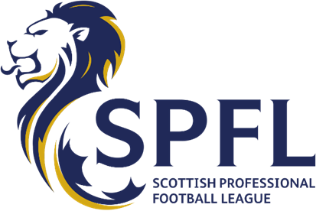

ND/MS
25 November 2020
The Rt Hon Nicola Sturgeon MSP
First Minister of Scotland
The Scottish Government
St Andrew’s House
Regent Road
Edinburgh
EH1 3DG
Dear First Minister
From your enthusiastic reaction to the magnificent achievement of the men’s Scottish
national team earlier this month, it’s clear you share a passion for our game.
I am sure you are equally keen to safeguard the very future of Scotland’s national sport, which
has been hit far harder by the lock-out than south of the border because it depends much
more heavily on gate receipts.
For almost nine months, and despite the enormous financial consequences, our clubs have
fastidiously followed every directive and every instruction from your Government. Clubs,
supporters and players have been hugely patient as we have played our full part in the
national effort to combat coronavirus.
However, with the very welcome news that clubs in England are being allowed to bring back
fans in limited numbers, we are seeking urgent talks with you to ensure that Scottish clubs,
and Scottish fans are permitted to do the same in very short order.
As you will know, every major club in Scotland has very detailed, well-founded plans in place
for safely returning fans back to stadiums. Thousands upon thousands of Scottish fans are
simply desperate to get back to watching their teams in the safety of a carefully-managed,
open-air environment. Apart from supporter safety, there is no higher priority for our game.
It’s now time to get the fans back.
Scottish football is on its knees and clubs big and small the length and breadth of the country
are in the most dire straits, with income projected to drop by £100 million this season alone.
Failure to get fans back in the very near future will sound the death knell for some of our bestloved clubs, which would be a tragedy on many levels, given the enormous contribution they
make to the economic, cultural and community life of our nation. No-one wants that to
happen.
Cont’d…/
Page 2
25 November 2020
The Rt Hon Nicola Sturgeon MSP
First Minister of Scotland
The Scottish Government
You alone have the chance to put a much-needed smile on the faces of millions of Scottish
football fans, giving them an early Christmas present by quickly approving the carefully managed return of fans across the country.
The response amongst Scottish supporters to the news about English football fans returning
has been resounding and, having taken extensive soundings at all levels of our game, I have
been asked to request an emergency meeting with you, because time is really against us.
Together with senior representatives from our clubs, we are entirely at your disposal. We will
meet with you under any circumstances, remotely or in person, day or night, to fit in with your
busy schedule and we eagerly await your response.
Yours sincerely
Neil Doncaster
Chief Executive

